*Florida International University*

*School of Computing and Information Sciences*

CIS 4911 - Senior Capstone Project

Software Engineering Focus

Feature Document

User Story # 706

**Team Member:**

Garrett Lemieux

**Product Owner(s)**:

Francisco Ortega

**Mentor(s)**:

Francisco Ortega

**Instructor**: Masoud Sadjadi

**User Story - Integrate Real Sense into Device Handler**

* As a User I would like to be informed when real sense is enabled in order to know what modes can be chosen and actions that can be made.
* **Acceptance Criteria**:

1. User Interaction UI must dynamically update when Real Sense has been connected or disconnected.

**Use Case: User can control real sense**

User wants to be informed when Real Sense device is enabled and receive feedback.

* Details:
* Actor:
  + User
* Pre-conditions:
  + Real Sense must be connected to TouchPoints application.
  + TouchPoints app is running.
* Description:
  + Use case begins when Real Sense has been connected or disconnected at any point application is running.
  + User can view connection status of devices within the UI display.
  + Use case ends when user exits application.
* Post-conditions:
  + Yellow rectangle should be present in UI display when real sense is connected.
  + Yellow rectangle should be absent in UI display when real sense is not connected
* Decision Support:
  + Frequency: Medium, User does not have to use real sense device.
  + Criticality: Medium, Other devices can be used to substitute the Real Sense device.
  + Risk: Low
* Usability:
  + User need to know what icons represent each device and how to pull up the Ui display.
  + Need to understand how UI works.
* Reliability
  + High
* Performance
  + Performance High
  + Failure Low
* Supportability
  + Real Sense Device
* Modification History:
  + Owner: Garrett Lemieux
  + Initiation Date 4/04/2016
  + Date last Modified: 4/16/2016

**Use Case Diagram**

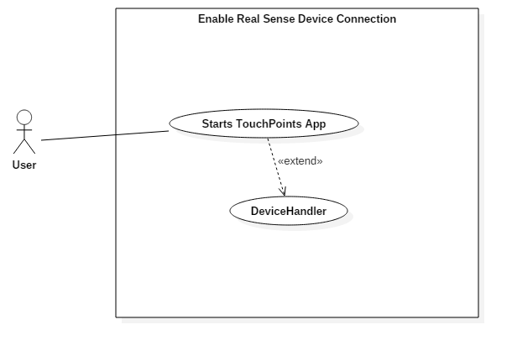

**Sequence Diagram**

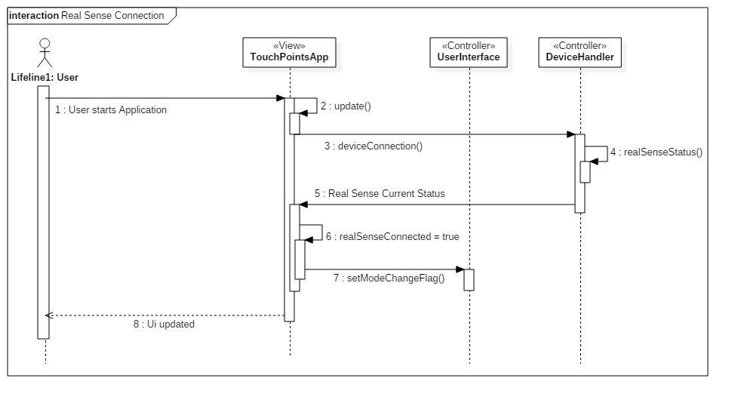

**Class Diagram**

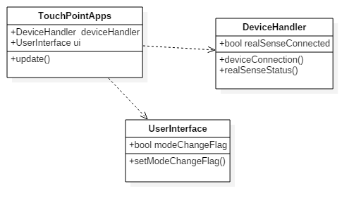

**Unit Test**

* Sunny Day Test:
  + Test Case  - Real Sense Connection
    - Test Purpose: To determine if user is provided feedback about Real Sense connection status.
    - Test Procedure: User plugs in Real Sense device and starts program. Then he or she checks Ui display.
    - Expected Results: Yellow box should appear in UI display.
* Rainy Day Test:
  + Test Case  - User unplugs Real Sense or device fails
    - Test Purpose: Test if correct feedback provided if user unplugs Real Sense or device fails.
    - Test Procedure: User unplugs Real Sense while application running.
    - Expected Results: Yellow box should disappear. If yellow box remains in Ui display test fails.

**Integration Testing**

* The User has the ability to know if the real sense device has been connected or disconnected and is automatically updated.
* The connection status of real sense was tested with all combinations of other devices.
* User is provided feedback and application is not dependent on Real Sense device connection.
* TouchPointsApp still functions correctly and other device’s connection statuses are independent of real sense and function correctly.

**User Guide**

* Devices Used: Real Sense Device

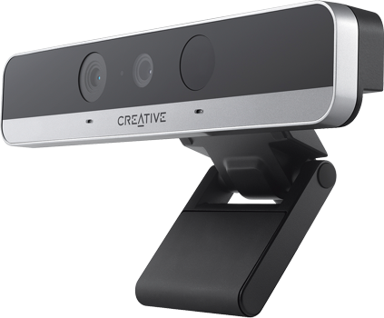

* In order for user to gain feedback from application he or she must enable UI display by using radial menu if default mode does not have the UI displayed automatically.
* Once UI display is active then the User will be informed of Real Sense device connection by a small box in left hand corner of UI display.
* If yellow box present then Real Sense device is connected.



* If yellow box absent then Real Sense device is disconnected.

